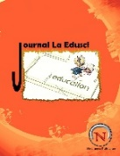 | JOurnal la EDUSCI  Vol. 07, Issue 04 (913-924), 2026  DOI: 10.37899/journallaedusci.v7i4.3110
Implementation of TPACK-Integrated Problem-Based Learning to Improve Students' Higher-Order Thinking Skills on Newton's Laws

Meltinur Asqory¹, Fibrika Rahmat Basuki¹, Dedi Sastradika¹
¹Universitas Islam Negeri Sulthan Thaha Saifuddin Jambi, Indonesia
*Corresponding Author: Meltinur Asqory
E-mail: melti241203@gmail.com
Article Info  Article history:  Received 13 February 2026  Received in revised form 24 March 2026  Accepted 17 June 2026  Keywords:  HOTS  PBL  TPACK  Physics Education  Newton’s Law |  | Abstract  The low Higher Order Thinking Skills of Indonesian students in Physics lessons encouraged the conduct of this quasi experimental research to investigate the influence of the problem based learning model integrated with technological pedagogical content knowledge on newton's law material. Involving 65 MAN 1 Jambi City students divided into three groups, the results of the kruskal wallis test showed a significant difference (p=0.000) with the technological pedagogical content knowledge integrated problem based learning experimental group achieving the highest average score (90.45) compared to the problem based learning group alone (81.36) and control (75.91). The integration of technologies such as PhET simulation and google sites has been proven to be significantly more effective in improving students' evaluation and creation skills. This study concludes that the combination of problem-based pedagogy with technological proficiency is the main key in transforming learning from memorization into critical and creative self discovery to face the digital era.
Introduction
High order thinking skills (HOTS) are one of the most important aspects to be developed in students (Kosasih et al., 2022; Kurniawan et al., 2024; Derakhshan & Taghizadeh, 2025). HOTS according to bloom's taxonomy includes the ability to analyze, evaluate, and create solutions to complex and real-life problems. These skills are needed so that students can compete in an increasingly rapidly evolving world, both in personal, social, and professional lives. Education that emphasizes HOTS has a great impact in preparing a generation that is able to face global challenges (Ragab et al., 2024; Ahmad et al., 2025; Ismeirita et al., 2025).
The importance of mastering HOTS is increasingly relevant in the context of the demographic bonus that Indonesia is experiencing (Pisriwati et al., 2024; Danis et al., 2025; Siregar, 2025). Based on data from the central statistics agency (BPS), in 2023 around 70.7% of Indonesia's total population will be included in the productive age group (15–64 years). This phenomenon is expected to last until 2040. This demographic bonus is a golden opportunity for Indonesia to accelerate economic growth and development, but it can turn into a serious challenge if the quality of human resources is inadequate. Without the provision of high-level thinking skills, students risk becoming a less competitive workforce and difficult to adapt to global demands (Rachman et al., 2022).
Despite its importance, the development of HOTS in Indonesia, especially in physics, still faces many challenges (Mardiana, 2024; Astalini et al., 2022; Mardiana et al., 2025). Based on the 2022 PISA report from the OECD, it states that the HOTS of Indonesian students is still relatively low, with an average score of only 19 out of 60, still far below the OECD average of 33. In addition, computer-based national assessment (ANBK) data in 2023 reveals that the average literacy and numeracy (AKM) ability of Indonesian students is still dominated by the basic or capable category. This means, even though many students have a basic understanding, they still have difficulty in dealing with HOTS questions that are part of AKM (Siregar & Siregar, 2025; Phibeta et al., 2025; Muharram et al., 2025).
The low level of thinking ability (HOTS) of students is caused by the dominance of learning methods that still focus on memorization rather than analysis and evaluation (Puspitasari, 2025; Rosmawati et al., 2025; Kusumadani et al., 2025). as well as the use of technology that is still limited and less interactive. This condition is exacerbated by constraints in the field, particularly in physics subjects, where learners tend to feel bored, find material difficult, and feel irrelevant, which significantly hinders their cognitive development ( Khmel & Shpyrka, 2025). Therefore, an innovative learning approach is needed that is able to shift memorization patterns towards the development of high-level thinking skills in understanding physics concepts in depth.
The results of the research, and stated that one of the learning models that can develop HOTS is problem base learning (PBL) (Danis et al., 2025; Taufiqurrahman et al., 2025; Gusmiyati, 2026). PBL is very effective in encouraging students to think deeply and meaningfully, especially when facing problems from their surroundings, because it will trigger group collaboration to develop cognitive capacity ranging from research to solution formulation. More so, PBL also encourages learners to process information on their own and build a personal understanding of the social environment and the world around them, thus making it the perfect model for developing knowledge (Okada et al., 2025; Firmansyah, 2025; Baum et al., 2024).
In the 21st century era and the industrial revolution 5.0, teachers are required to master and utilize technology in learning, using various technological devices, to facilitate the learning process. The use of technology in learning is very important to develop HOTS. This knowledge, which integrates the use of technology in learning, is known as technological pedagogical content knowledge (TPACK), and this approach is essential to improve the quality of learning processes and outcomes (Jibril & Adedokun-Shittu, 2024; Sihanita et al., 2024; Thohir et al., 2022). Various studies, both in Indonesia and abroad, have researched a lot about TPACK. Some of these are research by (Joshi, 2023) that confirms and expands understanding of how TPACK empowers teachers to face the challenges of teaching in the digital age.
However, the existing literature suggests that research on increasing HOTS through PBL and TPACK is often conducted separately. Previous research has generally explored how PBL is effective in encouraging HOTS through problem-solving and teamwork. Meanwhile, studies on TPACK have more emphasis on the role of technology integration in teachers' teaching methods to improve the quality of learning and outcomes, including HOTS. There is a gap in previous research, namely the lack of research that clearly examines how the combination of PBL and TPACK can increase students' HOTS, especially in physics lessons that are often considered difficult (Turnuklu & Yesildere, 2007).
Seeing the lack of studies that specifically integrate PBL and TPACK, this study is here to fill this gap by investigating how the application of PBL integrated with TPACK can increase the HOTS of students in class XI MAN 1 Jambi City on newton's legal material. The novelty of this research lies in the integration of PBL and TPACK, which not only tests the effectiveness of PBL, but also analyzes the role of TPACK in optimizing its implementation. Thus, this research is expected to make a significant contribution to formulating physics learning strategies that are more relevant and adaptive in the digital era, as well as a foothold for curriculum development and teacher training that focuses on integrating pedagogy, content, and technology to produce a generation that is not only cognitively intelligent, but also ready to face real world complexities.
Methods
This study employed a quasi experimental method using a three group pretest posttest design to examine the effectiveness of Problem Based Learning integrated with Technological Pedagogical Content Knowledge (TPACK) in improving students’ Higher Order Thinking Skills (HOTS) on Newton’s Law material. The study was conducted at MAN 1 Jambi City during the 2025 academic year.
The population consisted of all Grade XI students enrolled in physics classes at MAN 1 Jambi City. Since the population size was relatively small, total sampling was employed. A total of 65 students participated in the study and were distributed across three existing classes. Class XI.A, consisting of 22 students, was assigned as Experimental Group 1 and received instruction through TPACK integrated Problem Based Learning. Class XI.B, consisting of 22 students, served as Experimental Group 2 and received instruction through Problem Based Learning without explicit TPACK integration. Class XI.C, consisting of 21 students, served as the control group and was taught using conventional teacher centered instruction.
The independent variable of the study was the learning model implemented in each class, while the dependent variable was students’ Higher Order Thinking Skills (HOTS). HOTS was assessed according to the revised Bloom’s Taxonomy, focusing on three cognitive dimensions, namely analyzing (C4), evaluating (C5), and creating (C6).
To measure students’ HOTS, a pretest and posttest were administered before and after the instructional intervention. The test instrument consisted of essay and problem solving items related to Newton’s Laws designed to assess students’ abilities in analyzing physical phenomena, evaluating alternative solutions, and generating scientific explanations. The same HOTS indicators were used in both the pretest and posttest to enable comparison of learning gains across groups.
The instructional intervention was implemented during the Newton’s Law unit. In Experimental Group 1, Problem Based Learning activities were integrated with TPACK principles through the use of various digital learning technologies, including PhET simulations, Google Sites, Baamboozle, and ClassDojo. These technologies were utilized to facilitate problem exploration, concept visualization, collaborative investigation, formative assessment, and classroom interaction. In Experimental Group 2, students engaged in Problem Based Learning activities following the same problem solving stages but without the integration of digital technologies. Meanwhile, students in the control group received conventional instruction consisting primarily of teacher explanation, textbook based learning, and question answer activities.
The collected data were analyzed quantitatively using descriptive and inferential statistics. Descriptive statistics included the calculation of mean scores, standard deviations, variances, minimum scores, and maximum scores for both pretest and posttest results. Prior to hypothesis testing, assumption testing was conducted. Data normality was examined using the Shapiro Wilk test, while homogeneity of variance was assessed through Levene’s Test. The normality analysis indicated significance values below 0.05 in all groups, suggesting that the posttest data were not normally distributed. Although visual inspection through Normal Q-Q Plots indicated that the deviations from normality were not severe, the violation of the normality assumption justified the use of nonparametric statistical procedures. The homogeneity test produced a significance value of 0.331, indicating homogeneous variances among groups.
Consequently, differences in HOTS achievement among the three groups were analyzed using the Kruskal Wallis H test. When significant differences were identified, pairwise comparisons were conducted using post hoc analysis to determine which groups differed significantly from one another. In addition, effect size analysis was performed using Epsilon Squared (ε²) to determine the magnitude of the practical effect of the intervention. Statistical analyses were conducted using SPSS software with a significance level of 0.05.
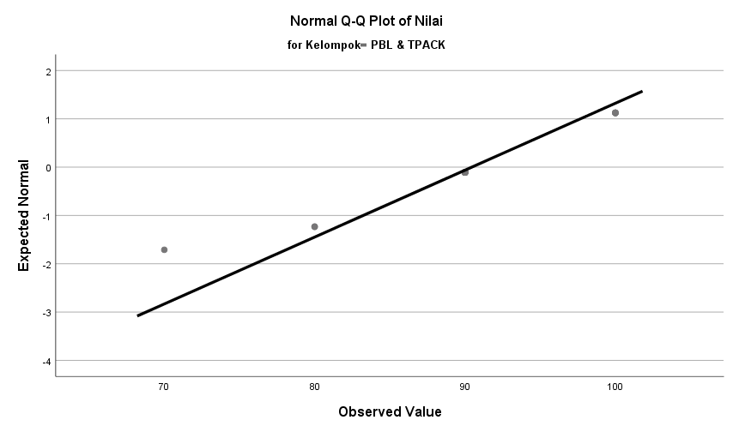 | 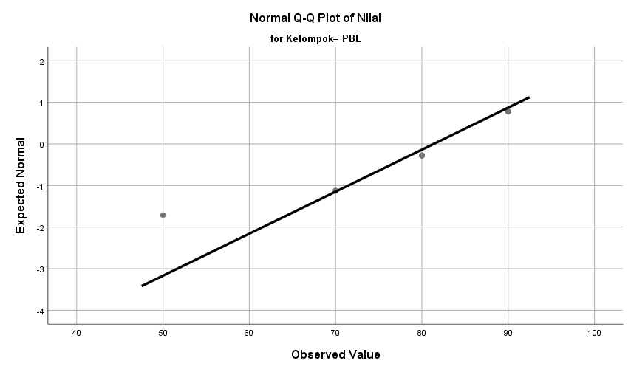 | 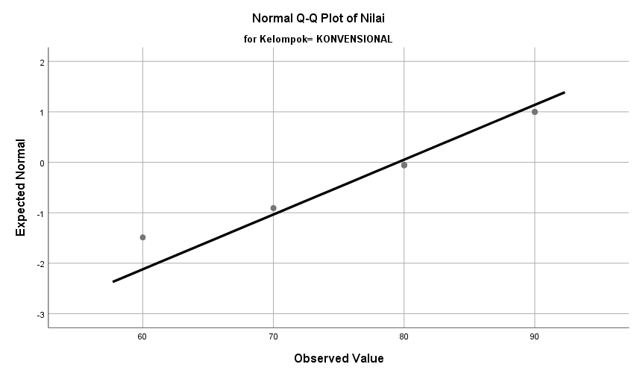
Figure 1. Normal Q-Q Plot Value Distribution in Each Group
Results and Discussion
Data on Pretest and Posttest Results of Experimental and Control Classes
The data on the results of the pretest and posttest of the experimental and control classes can be seen in table 1 below.
Table 1. Pretest and Posttest Result Data
Data | Pretest |  |  | Posttest
Data | E1 | E2 | K | E1 | E2 | K
Number of Students | 22 | 22 | 21 | 22 | 22 | 21
Highest Score | 60 | 60 | 50 | 100 | 90 | 90
Lowest Score | 10 | 10 | 10 | 70 | 50 | 60
Average | 38,86 | 31,36 | 28,57 | 90,45 | 81,36 | 79,52
Standard Deviation | 14,42 | 12,46 | 9,10 | 9,82 | 10,00 | 10,03
Varians | 207,9 | 155,2 | 82,8 | 96,43 | 100,0 | 100,6
The results of the data analysis showed that in the pretest stage, experimental group 1 had the highest average (38.86) with the largest score variation, but after being treated at the posttest stage, this group achieved the most optimal improvement in learning outcomes with the highest average of 90.45 and a better level of value homogeneity (smallest standard deviation 9.82) compared to experimental group 2 (81.36) and control group (79, 52). This shows a tendency that the application of the PBL model integrated with TPACK has a higher effectiveness in improving student learning outcomes compared to the use of PBL models without TPACK or conventional methods in the context of this study.
Pretest and Posttest Results Data Based on Higher Order Thinking Skills (HOTS) Indicators of Experiment and Control Class
The data on the results of the pretest and posttest based on HOTS indicators of the experimental and control classes can be seen in the following table:
Table 2. Recapitulation of Average Pretest and Posttest Scores
Groups | Test Time | Level Kognitif |  |  | Total Average
Groups | Test Time | C4 | C5 | C6 | Total Average
Experiential1 (PBL + TPACK) | Pretest | 2,73 | 28,18 | 7,95 | 38,86
Experiential1 (PBL + TPACK) | Posttest | 17,73 | 55,00 | 17,73 | 90,46
Ekperimen 2 (PBL) | Pretest | 2,27 | 24,09 | 5,00 | 31,36
Ekperimen 2 (PBL) | Posttest | 15,91 | 51,36 | 14,09 | 81,36
Control Class  (Conventional) | Pretest | 2,73 | 20,45 | 4,09 | 27,27
Control Class  (Conventional) | Posttest | 15,45 | 48,18 | 12,27 | 75,91
The test results showed that the students' initial HOTS ability in all classes was relatively low, but after treatment, experimental class 1 (TPACK-integrated PBL) achieved the best performance with an average posttest of 90.46, outperforming the non-technology PBL class (81.36) and the conventional class (75.91). Significant advantages can be seen in the indicators of evaluating and creating, where the integration of technology effectively helps visualize abstract concepts so that it is able to trigger students' creativity and critical thinking skills more optimally than other learning models.
Results of Analysis of Kruskal Wallis Test Using SPSS
Before testing the hypothesis in a non-parametric manner, an overview of the distribution of value data posttest In the three research groups, it can be seen in the following table 3.
Table 3. Descriptive Statistics
Variabel | N | Mean | Std.Deviation | Minimum | Maximum
Nilai Posttest | 65 | 83,85 | 9,952 | 50 | 100
Groups | 65 | 1,98 | 0,820 | 1 | 3
Table 3 shows that the total sample involved in this study was 65 respondents spread across three research groups. The overall mean score for the posttest score was 83.85 with a standard deviation of 9.952, indicating a variation in the distribution of data around the mean score. In addition, the data shows a fairly wide range of scores with a minimum score of 50 and a maximum score of 100. This descriptive data provides an initial foundation that there is a diversity of student achievement before it is further tested using the kruskal wallis test to determine the significance of differences between these groups. As the initial stage of the Kruskal Wallis test, the average score is calculated for each group so that it can compare the scores between the learning models, as seen in the following table 4.
Table 1. Average Posttest Score Rating
Groups | N | Mean Rank
PBL and TPACK | 22 | 45,82
PBL | 22 | 28,41
Conventional | 21 | 24,38
Total | 65
Table 4 shows a fairly significant difference in average ranking among the three study groups with 65 respondents. The experimental group that applied the PBL and TPACK models showed a striking advantage with the highest mean rank value of 45.82 (n=22). This value is far above the PBL control group which has a mean rank of 28.41 (n=22) and the conventional group which has the lowest rank of 24.38 (n=21). The high ranking scores in the PBL and TPACK groups show that descriptively, the TPACK integrated learning model makes a greater contribution to the achievement of students' posttest scores than the other two methods. To test whether the difference in average rating is statistically significant, a cross wallis hypothesis test was carried out whose results are as seen in the following table 5.

Table 2. Statistical Test Results
Statistical Test | Post Test Scores
Kruskal Valais H | 18,006
df (Degree of Freedom) | 2
Asymp.Sig (Significance) | ,000
Table 5 shows that the Kruskal value of Wallis H is 18.006 with a freedom level of 2. The significance value obtained was 0.000, smaller than the significance threshold of 0.05. This shows a statistically significant difference in post-secondary scores between the three groups, namely the experimental group, the PBL group, and the conventional group. This indicates that the difference in average ratings seen earlier is not purely coincidental, but is related to the variation in the treatment of the learning model applied in the context of this study.
Effect size analysis was carried out to measure the magnitude of the practical impact of the different learning models. Based on the calculation results, the Epsilon Squared value was obtained as 0.281. Referring to the Cohen criteria, this value is in the category of large securities beyond the threshold of 0.26. These results show that the difference in HOTS scores between groups is not just a theoretical difference in numbers, but has a strong and real influence practically on the learning process in the classroom. To identify which group pairs have significant differences, pairing comparisons are performed with the results presented in the following table.
Tabel 6. Pairwise Comparisons
Group Comparison | Test Statistic | Std.Error | Sig | Adj.Sig | Conclusion
Conventional vs PBL (3-2) | 4,028 | 5,399 | ,456 | 1,000 | Insignificant
Conventional vs PBL & TPACK (3-1) | 21,437 | 5,399 | ,000 | ,000 | Signifikan
PBL vs PBL & TPACK (2-1) | 17,409 | 5,336 | ,001 | ,003 | Signifikan
Based on table 6, it is shown that there is a significant difference in posttest values between the group that applied the PBL and TPACK methods and the group that applied the conventional model (p = 0.000) and between the group that applied PBL and TPACK and the group that applied PBL (p = 0.003). However, no significant differences were found between the group that applied PBL and the group that applied conventional (p = 1,000). This indicates that the use of the PBL model combined with TPACK is most effective in improving student learning outcomes.
Based on the results of the study, the application of the PBL model integrated with TPACK in experimental group 1 was proven to be able to significantly increase the HOTS of students. This is evidenced by the average value posttest experimental group 1 which reached 90.45. This value was higher than that of the experimental group 2 of 81.36 and the control group of 75.91. This proves that the integration of technology in PBL plays an important role in helping students understand the material (Lavonen et al., 2023).
The effectiveness of this model is in line with constructivist theory which states that knowledge is not simply received, but is built through active experience in problem solving ( Kraft-Terry & Wiebe, 2023). In the context of PBL that is integrated with TPACK, the process of understanding students' concepts becomes more real with the help of digital devices such as PhET simulation and google sites. The use of this technology helps students visualize the material better, so that the learning process becomes more meaningful (Banda & Nzabahimana, 2023). In line with this, these findings support the TPACK framework that the integration of technology, pedagogy, and content is capable of creating innovative learning models that go beyond conventional methods (Promwongsai & Poonputta, 2023). This integration is clearly seen in the evaluating indicator, which recorded the highest score of 55.00 in experimental group 1. This achievement reinforces Anderson and Krathwohl's theory that the ability to evaluate demands the skills of examining and criticizing in depth
The improvement in evaluation ability also penetrated into the creation indicator, where experimental group 1 achieved a score of 17.73, better than the control group which only reached 12.27. This ability at the C6 level is seen when students formulate strategies to achieve certain accelerations or design free-body diagrams accurately. This proves that TPACK integration helps students to think more critically and innovatively (Mgeladze et al., 2024). These findings are in line with research (Baziukė et al., 2025) which states that the combination of PBL with interactive media is able to hone complex problem-solving skills that demand creative thinking.
The results of the Kruskal Wallis statistical test strengthened the findings of the study with a significance value of 0.000, which means that there is a significant difference between groups. The Highest Mean Rank in experimental group 1 (45.82) showed that the PBL model integrated with TPACK provided better and consistent learning outcomes than other models. These results reinforce the research (Praviesta et al., 2024) which provides quantitative evidence on the effectiveness of TPACK's integrated PBL in improving learning outcomes compared to conventional methods. This success is essentially driven by compatibility between PBL syntax and proper technology support (Susilawati et al., 2025).
However, further test results on the paired comparison of the test showed that there was no significant difference between the PBL-only group (E2) and the conventional group (K) with a value of p = 1,000. This condition is suspected to be related to the limited duration of the intervention, the emergence of the phenomenon Learning Culture Shock, and it is not optimal Fidelity Implementation in the application of PBL in the field. It also indicates that without technology integration (TPACK), the PBL model has not been able to provide a significant difference in results compared to conventional methods. This is in line with Shulman's (1986) theory(Nupen & Jagernath, 2024) that in the digital era, pedagogical knowledge (PK) must be integrated with technological knowledge (TK) to produce meaningful and effective learning.
The need for this technology is reaffirmed by research (Sahidin & Prajono, 2022) about the importance of the role of media in increasing HOTS. The significant advantage of the TPACK group in evaluating (C5) and creating (C6) indicators indicates that the technology in this study does not only function as a tool, but as a cognitive scaffolding. The use of PhET simulations, for example, acts as a support that helps students overcome visualization difficulties in abstract concepts that tend to be difficult to reach for pure PBL groups. As Scaffold, technology provides a more 'secure' and scalable environment of inquiry, allowing learners to conduct repeated virtual experiments to test their hypotheses independently.
This transformative support helps students overcome their cognitive barriers, so that the evaluation and creation process can occur more optimally than in the group that only relies on PBL instruction without technological support. In this study, the use of PhET, baamboozle, and classdojo simulations proved to be effective as interactive media that triggered student activities. This shows that the success of HOTS development is highly dependent on the accuracy of teachers in integrating technology into the content of the material or knowledge of the content of the technology content (Yanuarto et al., 2023).
In addition to media accuracy, student activities during learning are also an important factor in increasing HOTS. In line with research (Khaira, 2023), active student activities are able to create a healthy and productive learning environment. For example, the use of google sites At the investigation stage, students are encouraged to remain focused and enthusiastic in identifying Newton's legal concepts. This kind of active participation is a prerequisite for achieving HOTS, because analytical and evaluation skills can only develop if learners are fully involved in the search for solutions, rather than simply passive recipients of information (NasirpourOsgoei & Obembe, 2025).
The effectiveness of this model is also seen in the analysis indicator which increased drastically from a pretest score of 2.73 to 17.73 in the posttest of experimental group 1. This increase shows the success of the stage of organizing learning tasks, where students are trained to decipher the elements of force in the situation of inclined planes and dependent objects. In accordance with the revised bloom taxonomy, the process of decomposing the material into small components is greatly helped by the visualization of PPt and PhET simulation. Without the support of technology, learners tend to have difficulty distinguishing complex information, as experienced by the control group.
This research also supports the view that HOTS is very important to equip students to face future challenges. The achievement of a maximum score of 100 in experimental group 1 shows that every student, regardless of their ability background, has the potential to achieve the highest cognitive level if supported by a learning model that is adaptive to technology. The results of this study prove that the PBL model integrated with TPACK not only increases grades, but also invites students to find answers directly (Tanjung et al., 2022).
The quantitative data in this study confirms that the integration of PBL and TPACK models is an approach that is relevant to global education trends in honing 21st century competencies. The integration between real-world problem solving processes and technological sophistication not only turns physics learning into a challenging discovery process, but also has an impact in the form of increasing grades as well as strengthening critical thinking and creativity that equips students with the ability of HOTS to become independent and innovative thinkers in the future.
Conclusion
The application of the TPACK integrated PBL model has proven to significantly increase the HOTS of grade XI MAN 1 Jambi City students in Newton's legal material, with the highest average posttest score (90.45) compared to the pure PBL (81.36) and conventional (75.91) models. The use of technology such as PhET simulations and google sites is the main key in helping visualize abstract concepts and optimize the ability to evaluate and create. The results of the study confirm that the synergy between problem-based pedagogy and teachers' technological proficiency is very effective in transforming memorization learning patterns into a critical and creative process of self-discovery in the digital era. Therefore, educators are encouraged to integrate interactive technology into the PBL syntax, supported by the provision of facilities and continuous TPACK training by schools. Future researchers are also suggested to employ a qualitative approach to further explore the learning process, implementation constraints, and students' perceptions of TPACK integrated PBL.
References
Ahmad, A., Ruslan, R., & Nasaruddin, N. (2025). Building critical and moral generation: The implementation of HOTS approach in Islamic religious education. Journal of English Language and Education, 10(1), 476-490. https://doi.org/10.31004/jele.v10i1.656
Astalini, A., Darmaji, D., Kurniawan, D. A., & Minarsih, M. (2022). Identification of HOTS creative thinking, science process skills and digital literacy in physics subject. Jurnal Penelitian Fisika Dan Aplikasinya (JPFA), 12(1), 47-61. https://doi.org/10.26740/jpfa.v12n1.p47-61
Banda, H. J., & Nzabahimana, J. (2023). The impact of Physics Education Technology (PhET) interactive simulation-based learning on motivation and academic achievement among Malawian physics students. Journal of Science Education and Technology, 32(1), 127–141. https://doi.org/10.1007/s10956-022-10010-3
Baum, C. M., Christiansen, C. H., & Bass, J. D. (2024). The person-environment-occupation-performance (PEOP) model. In Occupational therapy (pp. 47-55). Routledge.
Baziukė, D., Rupšienė, I., Kesylė, K., & Norvilienė, A. (2025). How e-learning platforms are addressing project-based learning: An assessment of digital learning tools in primary education. Applied Sciences, 15(23). https://doi.org/10.3390/app152312422
Danis, A., Julia, N. T., Maulida, Z., & Nabila, N. (2025). IMPROVING STUDENTS'LITERACY SKILLS THROUGH THE DEVELOPMENT OF A PROBLEM-BASED LEARNING MODEL BASED ON HOTS. Jurnal Buah Hati, 12(2), 136-149. https://doi.org/10.46244/buahhati.v12i2.3452
Danis, A., Julia, N. T., Maulida, Z., & Nabila, N. (2025). IMPROVING STUDENTS'LITERACY SKILLS THROUGH THE DEVELOPMENT OF A PROBLEM-BASED LEARNING MODEL BASED ON HOTS. Jurnal Buah Hati, 12(2), 136-149. https://doi.org/10.46244/buahhati.v12i2.3452
Derakhshan, A., & Taghizadeh, M. S. (2025). Does Artificial Intelligence (AI) Nurture or Hinder Language Learners' Higher‐Order Thinking Skills (HOTS)? A Phenomenological Study on L2 Learners' Perspectives and Lived Experiences. International Journal of Applied Linguistics. https://doi.org/10.1111/ijal.12824
Firmansyah, F. (2025). The Purpose of Education from the Perspective of Hadith in Instilling Islamic Values Dynamically in Daily Life. AL GHAZALI: Jurnal Pendidikan Dan Pemikiran Islam, 5(2), 340-358.
Gusmiyati, T. F. (2026). IMPROVING LEARNING OUTCOMES ON PLANE AREA THROUGH HOTS-ORIENTED PROBLEM BASED LEARNING (PBL). Teaching and General Education Studies, 2(1), 112-122.
Ismeirita, I., Ahman, E., Dahlan, D., & Supendra, D. (2025). Identifying Key Factors Influencing the Development of Higher Order Thinking Skills (HOTS) in Students: A Systematic Literature Review. AL-ISHLAH: Jurnal Pendidikan, 17(3), 5242-5257. https://doi.org/10.35445/alishlah.v17i3.6627
Jibril, M., & Adedokun-Shittu, N. A. (2024). Enhancing education: A comprehensive framework for integrating technological pedagogical content knowledge (TPACK) into teaching and learning. Indonesian Journal of Multidiciplinary Research, 4(1), 181-188.
Khaira, N. (2023). Meningkatkan kemampuan berpikir kritis & hasil belajar menggunakan model PBL dengan pendekatan TPACK. Jurnal Pendidikan Sosial dan Konseling, 1(3), 515–521. https://doi.org/10.47233/jpdsk.v1i2.15
Khmel, N., & Shpyrka, Z. (2025). Studying chemistry at school: Overcoming challenges together. Journal of Vasyl Stefanyk Precarpathian National University, 12(1), 151–160. https://doi.org/10.15330/jpnu.12.1.151-160
Kosasih, A., Supriyadi, T., Firmansyah, M. I., & Rahminawati, N. (2022). Higher-order thinking skills in primary school. Journal of Ethnic and Cultural Studies, 9(1), 56-76.
Kraft-Terry, S. D., & Wiebe, B. (2023). Using problem-based learning for training and development. In Comprehensive Advisor Training and Development: Practices That Deliver (pp. 146–161). https://doi.org/10.4324/9781003443551-15
Kurniawan, E. S., Mundilarto, E. I., & Istiyono, E. (2024). Improving student higher order thinking skills using Synectic-HOTS-oriented learning model. Int J Eval & Res Educ ISSN, 2252(8822), 1133.
Kusumadani, A. I., Afandy, H., Agustina, L., Astuti, R., & Waluyo, M. (2025). Evaluation of Higher-Order Thinking Skills of Middle School Students on Vibration and Wave Topic Using Rasch Measurement. Jurnal Penelitian Pendidikan IPA, 11(5), 74-84. https://doi.org/10.29303/jppipa.v11i5.10900
Lavonen, J., Vera-Vasquez, C. G., Inkinen, J., Juuti, K., Salmela-Aro, K., & Villalba-Condori, K. (2023). Engaging students in secondary science learning through the scientific and engineering practices and use of digital tools. CEUR Workshop Proceedings, 3353, 92–100.
Mardiana, N. (2024, October). The Impact of Digital Literacy on Improving Physics HOTS in Indonesia. In International Conference on Emerging Trends in Science Education (Vol. 1, pp. 185-194).
Mardiana, N., Maulina, B., Mardiani, N., Sabar, S., & Collantes, L. M. (2025). Enhancing critical thinking skills through android-assisted virtual physics learning: A focus on hots development. Jurnal Ilmiah Ilmu Terapan Universitas Jambi, 9(2), 513-526. https://doi.org/10.22437/jiituj.v9i2.34373
Mgeladze, A., Kapanadze, M., & Chakhaia, L. (2024). From measuring to action: The next steps in physics teachers’ technological pedagogical content knowledge. Science Education International, 35(4), 429–438. https://doi.org/10.33828/sei.v35.i4.13
Muharram, M. R. W., Wahyudin, Lidinillah, D. A. M., & Mursyidah, D. (2025, November). Analysis of student errors in solving minimum competency assessment on scientific context numeracy competence using Newman’s error analysis procedure. In AIP Conference Proceedings (Vol. 3446, No. 1, p. 030045). AIP Publishing LLC.
NasirpourOsgoei, S. N., & Obembe, D. (2025). Enhancing academic performance through attendance and recognition: An active learning approach in UK higher education. Innovations in Education and Teaching International. https://doi.org/10.1080/14703297.2025.2539776
Nupen, D. M., & Jagernath, J. (2024). Digital integration insights: Exploring highlights and challenges of numeracy lecturers in higher education. Proceedings of the International Conference on Education Research (ICER 2024), 263–271.
Okada, A., Sherborne, T., Panselinas, G., & Kolionis, G. (2025). Fostering transversal skills through open schooling supported by the CARE-KNOW-DO pedagogical model and the UNESCO AI competencies framework. International Journal of Artificial Intelligence in Education, 1-46.
Phibeta, T., Ekawati, R., & Wintarti, A. (2025). Senior High School Students' Numeracy in Solving Number Content AKM Problems in View of Adversity Quotient. Jurnal Riset Pendidikan dan Inovasi Pembelajaran Matematika, 9(2), 182-196. https://doi.org/10.26740/jrpipm.v9n2.p182-196
Pisriwati, S. A., Siswanto, D. H., Hardi, Y., & Alghiffari, E. K. (2024). Question making training with LOTS, MOTS, and HOTS cognitive levels for high school teachers. Journal of Social and Community Development, 1(01), 9-18. https://doi.org/10.56741/jscd.v1i01.666
Praviesta, A., Handini, O., & Mustofa, M. (2024). Pengaruh model pembelajaran problem based learning (PBL) berbasis TPACK terhadap hasil belajar peserta didik kelas IV pada mata pelajaran IPAS SD Negeri 01 Munggur. Algoritma: Jurnal Matematika, Ilmu Pengetahuan Alam, Kebumian dan Angkasa, 2(6), 20–33. https://doi.org/10.62383/algoritma.v2i6.273
Promwongsai, A., & Poonputta, A. (2023). Investigating the effectiveness of TPACK and TGT in enhancing histogram learning achievement among eighth-grade students. International Journal of Innovative Research and Scientific Studies, 6(4), 1015–1022. https://doi.org/10.53894/ijirss.v6i4.2232
Puspitasari, M. (2025). Investigating EFL teachers’ perceptions on the implementation of higher order thinking skills in semi-urban area. Utamax: Journal of Ultimate Research and Trends in Education, 7(1), 1-11.
Ragab, A., Kaid, A., & Sayed, A. K. (2024). Enhancing higher order thinking skills (hots) in education: Strategies and outcomes. TOFEDU: The Future of Education Journal, 3(5), 1488-1499. https://doi.org/10.61445/tofedu.v3i5.267
Ramo, N. L., Hald, E. S., Huang-Saad, A., & Fang, Q. (2020). Work-in-progress: The development and implementation of self-reflection participation logs in an English-taught engineering program in China. ASEE Annual Conference and Exposition, Conference Proceedings.
Rosmawati, E., Wulandari, B. A., & Widowati, A. (2025). Feasibility study of daily test items for 5th grade IPAS based on Bloom's taxonomy in elementary school. Journal of Innovation and Research in Primary Education, 4(2), 94-102.
Sahidin, L., & Prajono, R. (2022). Eksplorasi TPACK dalam mendukung keterampilan berpikir tingkat tinggi (Exploration of TPACK in supporting high order thinking skills). Jurnal Pendidikan Matematika, 13(2), 212–227. https://doi.org/10.36709/jpm.v13i2.15
Sihanita, Y. K., Priambodo, A., & Tuasikal, A. R. S. (2024). TPCK (Technological pedagogical and content Knowledge) competence for educator: A literature review. EDUKASIA Jurnal Pendidikan Dan Pembelajaran, 5(2), 77-92. https://doi.org/10.62775/edukasia.v5i2.851
Siregar, N., & Siregar, R. S. (2025). Analysis of numeracy literacy of junior high school students in AKM questions: Learning strategies based on higher order thinking skills at SMP Negeri 5 Tapung Hilir. Jurnal Profesi Guru Indonesia, 2(1), 359-367. https://doi.org/10.62945/jpgi.v2i1.720
Siregar, T. (2025). Implementation of Problem-Based Learning (PBL) Model to Enhance Higher-Order Thinking Skills (HOTS). Available at SSRN 5709306.
Susilawati, S., Supriyatno, T., Yasin, A. F., Chakim, A., & Putri, C. A. (2025). The effect of TPACK-based contextual teaching and learning model on student learning outcomes. Educational Process: International Journal, 16. https://doi.org/10.22521/edupij.2025.16.279
Tanjung, S., Ampera, D., & Jahidin, I. (2022). Problem based learning (PBL) model with technological, pedagogical, and content knowledge (TPACK) approach. International Journal of Education in Mathematics, Science and Technology, 10(3), 740–752. https://doi.org/10.46328/ijemst.2510
Taufiqurrahman, T., Fathonah, S., Ahmadi, F., Arsyad, A. A., & Rahman, S. (2025). Problem-Based Learning Model Assisted by Interactive Media to Improve Students Higher Order Thinking Skills (HOTS). Jurnal Penelitian Pendidikan IPA, 11(1), 1234-1243. https://doi.org/10.29303/jppipa.v11i1.6649
Thohir, M. A., Jumadi, J., & Warsono, W. (2022). Technological pedagogical content knowledge (TPACK) of pre-service science teachers: A Delphi study. Journal of Research on Technology in Education, 54(1), 127-142. https://doi.org/10.1080/15391523.2020.1814908
Yanuarto, W. N., Hapsari, I., & Setyaningsih, E. (2023). Modeling the effect of higher-order thinking skills and technological pedagogical content knowledge on students’ digital literacy. Journal of Applied Structural Equation Modeling, 7(2). https://doi.org/10.47263/JASEM.7(6)06

